INNOVA JUNIOR COLLEGE
JC 2 PRELIMINARY EXAMINATION 2
in preparation for General Certificate of Education Advanced Level
Higher 2

CANDIDATE
NAME

CLASS INDEX NUMBER

CHEMISTRY  Paper 1 Multiple Choice  Additional Materials: Data Booklet  Multiple Choice Answer Sheet | 9647/01, 9746/01  20 September 2010  1 hour

READ THESE INSTRUCTIONS FIRST

Write your name and class on all the work you hand in.
Write in soft pencil.
Do not use staples, paper clips, highlighters, glue or correction fluid.

There are forty questions on this paper. Answer all questions. For each question there are four possible answers A, B, C and D.
Choose the one you consider correct and record your choice in soft pencil on the separate Answer Sheet.

Read the instructions on the Answer Sheet very carefully.

Each correct answer will score one mark. A mark will not be deducted for a wrong answer.
Any rough working should be done in this booklet.

This document consists of 17 printed pages and 1 blank page.
 | Innova Junior College | [Turn over

Section A

For each question there are four possible answers, A, B, C, and D. Choose the one you consider to be correct.

1 | When 20 cm³ of a gaseous hydrocarbon was completely burnt in an excess of oxygen, 60 cm³ of carbon dioxide and 40 cm³ of water vapour were formed. All volumes are measured at the same temperature and pressure.  What is the formula of the hydrocarbon?
 | A | C₃H₄ | C | C₃H₈
 | B | C₃H₆ | D | C₆H₈

2 | The use of Data Booklet is relevant to this question.  In research on the atomic nucleus, scientists have been comparing the stability of isotopes with the same neutron:proton ratio.  Which isotope has the same neutron:proton ratio as ¹⁰B?
 | A | ³²S | C | ⁴⁰Ar
 | B | ³²P | D | ⁴⁰K

3 | The use of Data Booklet is relevant to this question.  The successive ionisation energies, in kJ mol⁻¹, of an element A are given below.  What could element A be?
  870 | 1800 | 3000 | 3600 | 5800 | 7000 | 13200
 | A | ₅₁Sb | C | ₄₉In
 | B | ₄₀Zr | D | ₃₄Se

4 | Flask C contains 1 dm³ of helium at 2 kPa pressure and flask D contains 2 dm³ of neon at 1 kPa pressure.  If the flasks are connected at constant temperature, what is the final pressure?
 | A | 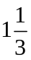 kPa | C | 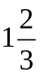 kPa
 | B | 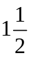 kPa | D | 2 kPa

5 | Which of the following molecules does not exist?
 | A | 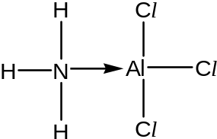 | C | 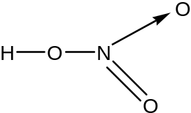
 | B | 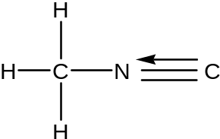 | D | 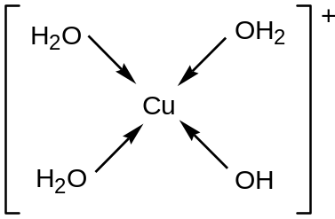

6 | Group II metals have lower melting points than the Group III metals. Which of the following factors can explain the above phenomena?
 | A | The atomic radius of Group II metals is smaller.
 | B | There are two valence electrons delocalised into the metallic lattice of Group II metals.
 | C | Group II metals have lower first ionisation energies.
 | D | The interatomic distances in the metal lattice lattices of Group II metals are smaller.

7 | The overall equation for the formation of the red coloured compound E₃G is given below.  3E₂ + G₂ 2E₃G  colourless colourless red  Two experiments were carried out and it was found that the rate of reaction is given by the following relationship:  Rate α 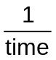  If the rate equation is found to be Rate = k[E₂][G₂], which of the following statements is not true?
 | A | A catalyst added will increase the rate of consumption of G₂.
 | B | The unit of the rate constant is mol⁻¹ dm³ min⁻¹.
 | C | One E₂ molecule and one G₂ molecule are involved in the rate determining step.
 | D | The rate of consumption of E₂ is three times higher than the rate of consumption of G₂.

8 | At temperature T K, the three equilibrium constants for each equilibrium are shown below.  Using the above equations, what is the numerical value of K_{c} for the following equilibrium at temperature T K?  3CO₂(g) + H₂(g) 3CO(g) + H₂O(g) + O₂(g)
  CO₂(g) + H₂(g) CO(g) + H₂O(g) | K₁ = 0.2
  C(s) + CO₂(g) 2CO(g) | K₂ = 6.2
  C(s) + O₂(g) CO(g) | K₃ = 3.3 x 10⁴
 | A | 4.8 x 10⁻¹⁰ | C | 9.3 x 10⁻⁶
 | B | 7.1 x 10⁻⁹ | D | 4.3 x 10

9 | The reaction between hydrogen and nitrogen in the Haber process is given below.  3H₂(g) + N₂(g) 2NH₃(g)  The forward and backward rate constants are given as k₁ and k₋₁ respectively. What happens to the equilibrium constant K_{p}, k₁ and k₋₁ if at equilibrium, the volume of the reaction vessel is decreased at constant temperature?
 |  | k₁ | k₋₁ | K_{p}
 | A | increases | increases | increases
 | B | unchanged | increases | unchanged
 | C | increases | increases | decreases
 | D | unchanged | unchanged | unchanged

10 | Which of the following graphs correctly represents the variation of pH against the volume of nitric acid added when 20.0 cm³ of a 0.2 mol dm⁻³ sodium carbonate solution is titrated against 0.2 mol dm⁻³ nitric acid using phenolphthalein and methyl orange indicators?
 | A | 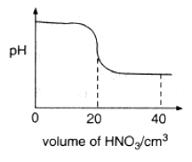 | C | 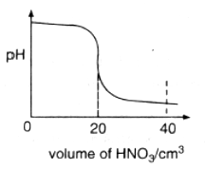
 | B | 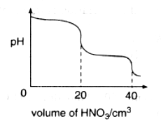 | D | 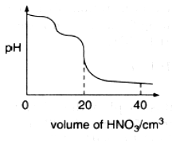

11 | The pH of a solution mixture containing equal amounts of aqueous ammonia and ammonium chloride is 9.26.  Which of the following happens when 2.0 cm³ of 0.10 mol dm⁻³ nitric acid is added to the mixture?
 | A | The pH of the resulting solution increases.
 | B | The number of moles of NH₄⁺ ions in the resulting solution increases.
 | C | The number of moles of NH₃ molecules in the resulting solution remains unchanged.
 | D | The ratio of moles of NH₄⁺ ions to NH₃ molecules in the resulting solution decreases.

12 | The radius and charge of six cations and anions are shown below.  If the ionic solids LM, JK and HI are of the same lattice type, what is the correct order of their lattice energies, placing the one with the highest numerical value first?
  Ion | L⁺ | J²⁺ | H²⁺ | M– | K^{2–} | I^{2–}
  Radius / pm | 220 | 170 | 140 | 180 | 150 | 200
 | A | HI, JK, LM | C | LM, JK, HI
 | B | HI, LM, JK | D | JK, HI, LM

13 | The enthalpy changes for two reactions are given by the equations below.  What is the enthalpy change when 1 kg of silver is obtained from the reduction of silver(I) oxide?  2Ag₂O(s) + C(s) 4Ag(s) + CO₂(g)
  2Ag(s) + O₂(g) Ag₂O(s) | ΔH = –31.0 kJ mol⁻¹
  C(s) + O₂(g) CO₂(g) | ΔH = –393.5 kJ mol⁻¹
 | A | –331.5 kJ mol⁻¹ | C | –850.4 kJ mol⁻¹
 | B | –767.4 kJ mol⁻¹ | D | –1054.4 kJ mol⁻¹

14 | The properties of the oxides of four Period 3 elements N, P, Q and R are given below.  Which of the following is correct in order of increasing proton number?
  The oxide of N is insoluble in water and in dilute acid but soluble in concentrated sodium hydroxide.
  The oxide of P is amphoteric.
  The oxide of Q reacts with dilute sodium hydroxide at room temperature.
  The oxide of R dissolves in water to form a strong alkaline solution.
 | A | R, P, N, Q | C | R, N, P, Q
 | B | N, P, Q, R | D | R, Q, N, P

15 | Which of the following statements regarding the chlorides MgCl₂, SiCl₄ and PCl₃ is correct?
 | A | All three chlorides hydrolyse completely in water to give acidic solution.
 | B | The oxidation states of chlorine in the three chlorides are –2, –4 and –3 respectively.
 | C | All are liquids at room temperature.
 | D | MgCl₂ is the only chloride having a giant structure.

16 | A student carried out an experiment in the following steps.  Which of the following will not be observed as the student carries out the steps above?
  1 |  | Add aqueous bromine to a solution containing an excess of sodium iodide.
  2 |  | Resulting mixture is shaken with an equal volume of an organic solvent.
  3 |  | Aqueous layer is then separated out and aqueous silver nitrate is added to it.
  4 |  | Mixture is filtered.
  5 |  | Concentrated aqueous ammonia is then added to the residue.
  6 |  | Resulting mixture is again filtered.
 | A | In step 1, the solution turned brown.
 | B | In step 2, a violet organic layer was obtained.
 | C | In step 3, a mixture of cream and white precipitate is obtained.
 | D | In step 6, yellow precipitate was obtained as the residue after filtration.

17 | An aqueous solution containing a mixture of copper(II), iron(II) and lead(II) ions are treated with an excess of aqueous ammonia.  Which of the following will be present in the precipitate?
 | A | copper(II) hydroxide only
 | B | iron(II) hydroxide only
 | C | lead(II) hydroxide only
 | D | iron(II) hydroxide and lead(II) hydroxide

18 | Radium is the last element of Group II in the Periodic Table. Which of the following is not true for radium?
 | A | It reacts with water to release hydrogen gas.
 | B | It is the least reactive element in Group II.
 | C | Its oxide is basic in water.
 | D | Its compounds conduct electricity when molten.

19 | Estragole is an organic compound found in the essential oils of various plants. It can be synthesised from chavicol, a compound used in perfumes.  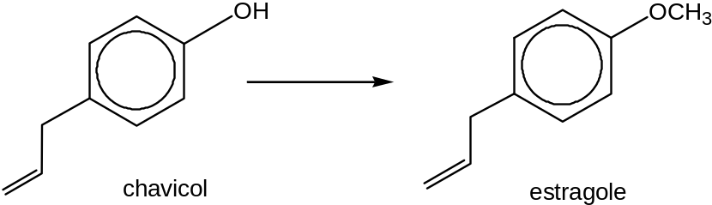  Which of the following reagents and conditions can be used to carry out the above conversion?
 | A | NaOH, followed by CH₃OH | C | NaOH, followed by CH₃Br
 | B | Na₂CO₃, followed by CH₃I | D | Na₂CO₃, followed by CH₃OH

20 | Carbonyl compounds undergo condensation reactions with 2,4 dinitrophenylhydrazine as shown in the equation below.  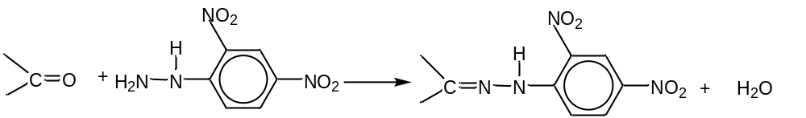  Which pair of compounds could be used to form the compound shown below?  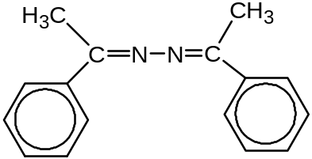
 | A | C₆H₅(CH₃)C=NH and C₆H₅(CH₃)C=NH
 | B | C₆H₅CHO and C₆H₅(CH₃)C=NNH₂
 | C | C₆H₅COCH₃ and H₂NNH₂
 | D | C₆H₅COCH₃ and C₆H₅(CH₃)C=NH

21 | The antibiotic chlortetracycline is commonly used to treat conjunctivitis in cats. It has the formula shown.  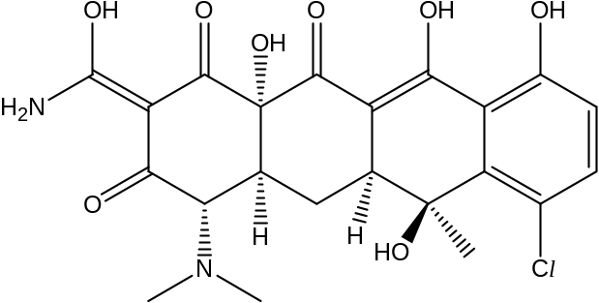  How many stereoisomers are possible for chlortetracycline?
 | A | 2⁴ | C | 2⁶
 | B | 2⁵ | D | 2⁷

22 | What is the number of sp² and sp³ carbon atoms in the structure given below?  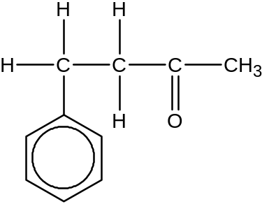
 |  | sp² | sp³
 | A | 7 | 3
 | B | 1 | 3
 | C | 4 | 6
 | D | 3 | 7

23 | A new industrial preparation of ethyl ethanoate has been developed using cheap sources of ethanol.  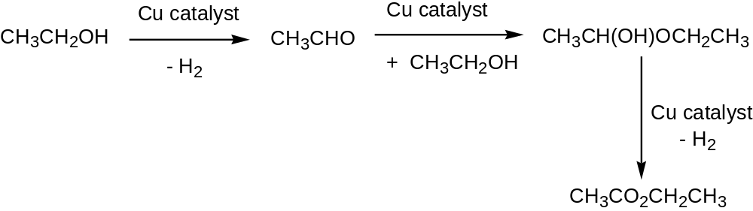  Which process is involved at some stage in this reaction sequence?
 | A | disproportionation
 | B | electrophilic addition
 | C | nucleophilic addition
 | D | reduction

24 | Concentrated sulfuric acid is often used in organic reactions as a strong acid, dehydrating agent, catalyst or oxidising agent.  In which of the following reactions is concentrated sulfuric acid not acting in one of the above functions?
 | A | 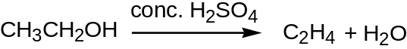
 | B
 | C | 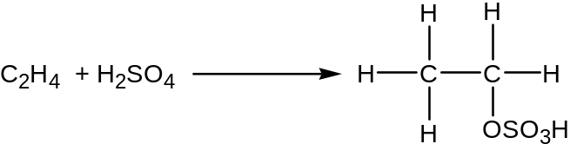
 | D

25 | A certain organic compound reacts vigorously with water to give an acidic solution which instantly yields a precipitate of silver bromide when treated with aqueous silver nitrate. What could be the compound?
 | A | BrCH₂CH₂COOH | C | CH₃CH₂COBr
 | B | C₆H₅Br | D | CH₃CH(OH)CH₂Br

26 | Chlorofluroalkanes, commonly known as CFCs, undergo homolytic fission in the presence of ultraviolet radiation in the stratosphere.  Which radical is likely to be produced from the radiation on CHFClCF₂Cl?
 | A | 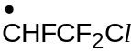
 | B | 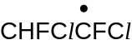
 | C | 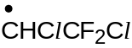
 | D | 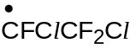

27 | When ethene reacts with HBr in the presence of aqueous NaNO₃, what are the two possible products formed?
 | A | 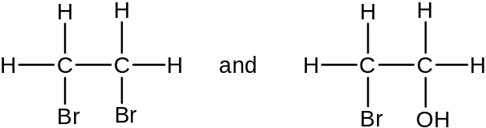
 | B | 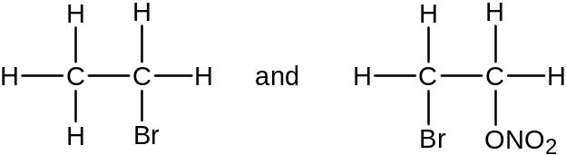
 | C | 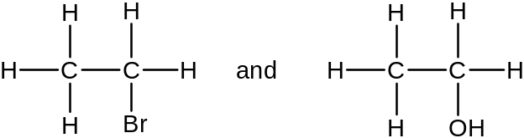
 | D | 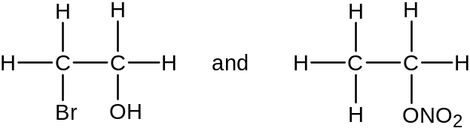

28 | In the tertiary structure of a water-soluble globular protein extracted from barley grains, it was found that the types of amino acid residues present on the outer surface of the protein were different from those present on the inside.  Which of the following amino acids is most likely to be incorporated into the outer surface of such proteins?
 | A | 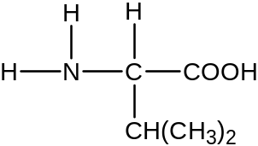 | C | 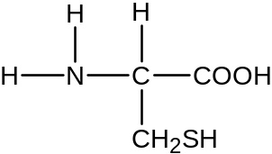
 | B | 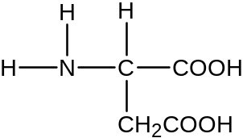 | D | 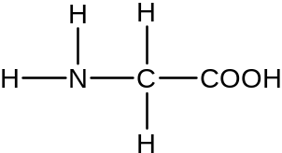

29 | The psychoactive drug in cannabis has the following structure.  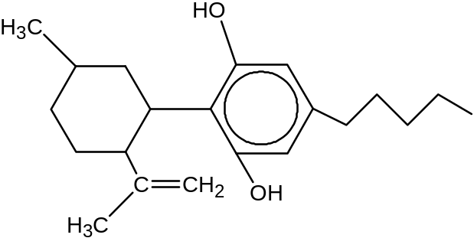  Which statement about the above molecule is incorrect?
 | A | Effervescence is observed when heated with purple potassium permanganate (VII).
 | B | It has 8 stereoisomers.
 | C | It produces 5 moles of HBr when reacted with aqueous bromine under room temperature.
 | D | The solubility of the compound increases in aqueous NaOH.

30 | Glutamic acid has a pK_{a} value of 4.3 and residues of this amino acid are present in the β-chains of haemoglobin.  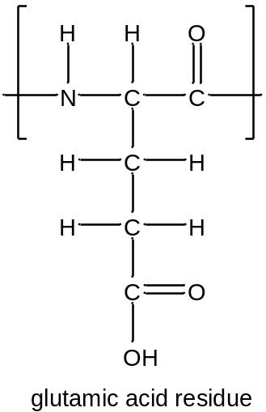  Which of the following structures shows glutamic acid residue in its most stable state when a sample of haemoglobin is hydrolysed and the solution is subsequently adjusted to pH=7?
 | A | 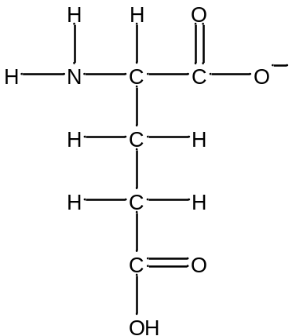 | C | 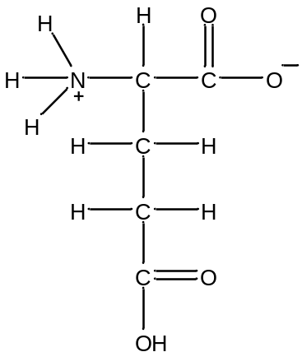
 | B | 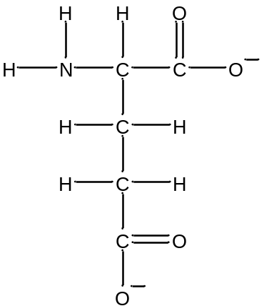 | D | 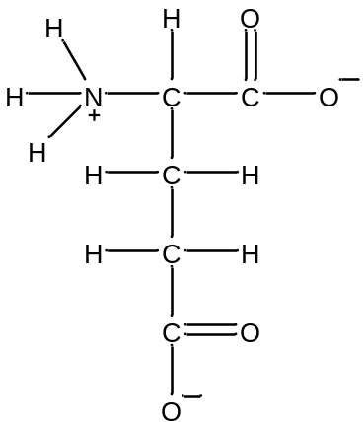

Section B

For each of the questions in this section, one or more of the three numbered statements 1 to 3 may be correct.

Decide whether each of the statements is or is not correct (you may find it helpful to put a tick against the statements that you consider to be correct).

The responses A to D should be selected on the basis of

A | B | C | D
1, 2 and 3 are correct | 1 and 2 only are correct | 2 and 3 only are correct | 1 only is correct

No other combination of statements is used as a correct response.

31 | A 2 g sample of hydrogen gas at temperature T and volume V exerts a pressure p. Deuterium, ²H, is an isotope of hydrogen. Which of the following would also exert a pressure p at the same temperature T?
 | 1 | 2 g of deuterium of volume V
 | 2 | 4 g of deuterium of volume V
 | 3 | A mixture of 1 g of hydrogen and 2 g of deuterium of total volume V

32 | Which of the following statements are correct?
 | 1 | The bond angle in NH₃ is larger than the bond angle in BF₃.
 | 2 | The bond angle in CO₂ is larger than the bond angle in SO₂.
 | 3 | The bond angle in NH₃ is larger than the bond angle in NF₃.

33 | Which of the following statements about ionic compounds are correct?
 | 1 | All ionic compounds are readily soluble in water.
 | 2 | All ionic compounds are solids at room temperature.
 | 3 | All ionic compounds do not conduct electricity in the solid state.

34 | The reaction between bromine and ethane under ultraviolet light is represented by the equation below:  C₂H₆ + Br₂ 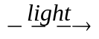 C₂H₅Br + HBr  From the information above, what can be concluded regarding the rate of formation of hydrogen bromide?
  Experiment | Initial concentration/ mol |  | Light intensity | Initial rate of HBr formation
  Experiment | C₂H₆ | Br₂ | Light intensity | Initial rate of HBr formation
  1  2  3  4 | 2  2  1  1 | 1  1  1  2 | 4  1  4  4 | 2  1  1  1
 | 1 | It is directly proportional to the square root of light intensity.
 | 2 | It is not dependent on the initial concentration of bromine.
 | 3 | It is directly proportional to the initial concentration of ethane.

35 | The standard reduction electrode potential for three half-cell reactions at 298 K are shown below.  Which of the following can be concluded from the above data?
  Half-cell reaction | E^{θ} /V
  Sn⁴⁺ + 2e Sn²⁺ | +0.15
  Zn²⁺ + 2e Zn | –0.76
  2 IO₃⁻ + 12H⁺ + 10e I₂ + 6H₂O | +1.19
 | 1 | Iodate(V) is the strongest oxidizing agent.
 | 2 | Zinc can reduce tin(IV) to tin(II) ions.
 | 3 | Iodine will be formed when Sn²⁺ is added to KIO₃.

The responses A, B, C, and D should be selected on the basis of
A | B | C | D
1, 2 and 3  are correct | 1 and 2  only are correct | 2 and 3  only are correct | 1 only  is correct

No other combination of statements is used as a correct response.

36 | This question is about the chemistry of Group VII elements. Which of the following statements are correct?
 | 1 | The halogens all form hydrides that are acids in aqueous solutions.
 | 2 | The reactivity of halogens as oxidising agents decreases on descending the group.
 | 3 | The reaction between concentrated sulfuric acid and potassium chloride is that of a redox reaction.

37 | This question is about the chemistry of Group II elements. Which of the following properties increases with increasing atomic number?
 | 1 | Reducing power of the elements
 | 2 | Magnitude of the enthalpy change of hydration of the metal ions
 | 3 | Covalent character in the compounds of the elements

38 | Lycra is a polyurethane fibre widely used in sportswear and fashion. A repeat unit of the polymer is shown below. (The values of x and y are usually between 3 and 8.)  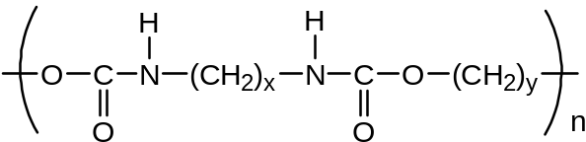  What are the organic products formed when Lycra is heated with aqueous NaOH?
 | 1 | 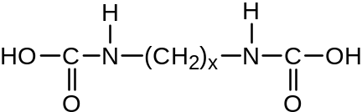
 | 2 | 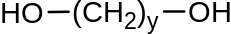
 | 3 | 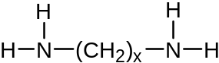

39 | Consider the following reaction.  (CH₃)₃SiCl + CH₃CH₂O–Na⁺ (CH₃)₃SiOCH₂CH₃ + Cl–  Which of the following statements are likely to be true?
 | 1 | The reaction involves a nucleophilic attack by the ethoxide ion.
 | 2 | Chlorine is displaced by the ethoxide ion.
 | 3 | The carbon-oxygen bond is broken.

40 | Tert-butyl-bromide can form a Grignard reagent by reacting with magnesium metal.  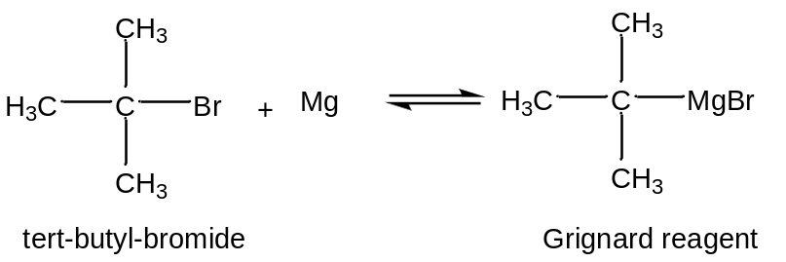  Because magnesium is more electropositive than carbon, the carbon-magnesium is polarised C^{δ–}–Mg ^{δ+}.  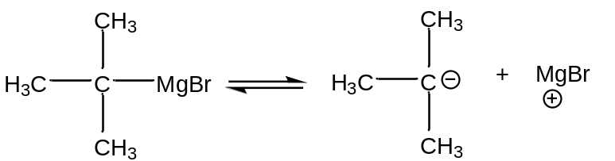  The Grignard reagent can subsequently react with water as shown in reaction I.  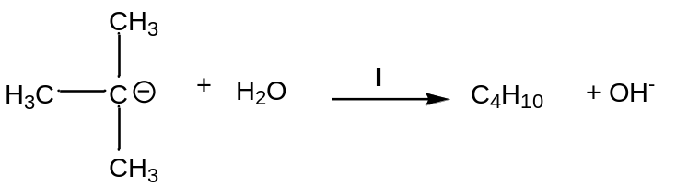  Which of the following statements are correct?
 | 1 | Reaction I is an acid-base reaction.
 | 2 | The product of reaction I is (CH₃)₃CH.
 | 3 | Carbonyl compounds react with Grignard reagents via nucleophilic addition.

BLANK PAGE

